PLORAS Participant Consent Form
Version: 8.0 | Date: 21.08.2023
Study title: | Predicting Language Outcome and Recovery After Stroke (PLORAS)
Chief Investigator: | Cathy Price | UCLH R&D Project ID: | 13/0435
IRAS Project ID: | 133939 | Research Ethics Committee ref: | 13/LO/1515

Notes
- This form is to be completed by a research practitioner with the participant.
- Before completing, the participant should have been provided with the PLORAS Information Booklet (version 6.0, 13.10.2022), Privacy Notice (version 2.0, 13.10.2022), and understood the PLORAS Information Summary Sheet (version 2.0, 18.08.2023) – see Consent Flowchart in the PLORAS protocol.
- Part 1 is required for all participants.
- Part 2 can be left blank if it is difficult to complete at your site. In these cases, the PLORAS team will complete it with the participant.
Participant details [BLOCK CAPITALS]
Title:
First name:
Last name:
Date of birth:
NHS number:
Email*:
Landline*:
Mobile*:
Address:

(*please note, email and telephone are the primary method of contact with PLORAS)

Part 1: First stage consent
- The relevant boxes below should be initialled by the participant.
- Please see note on Page 5 on when an Independent witness may be appropriate.

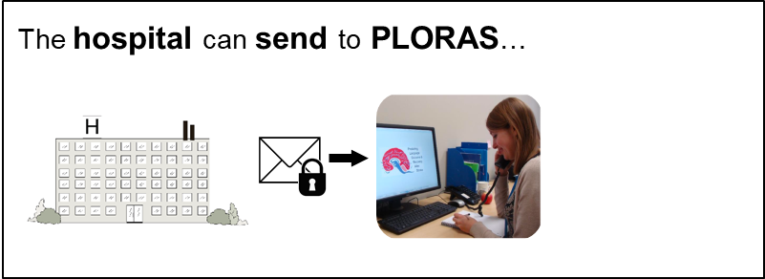
1.

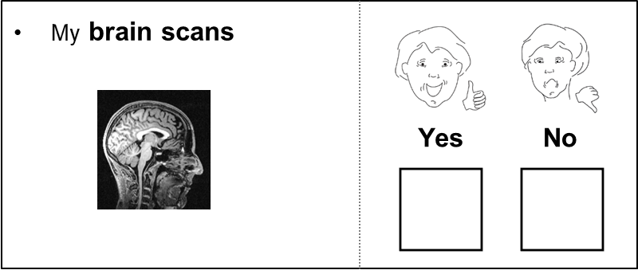
1a.

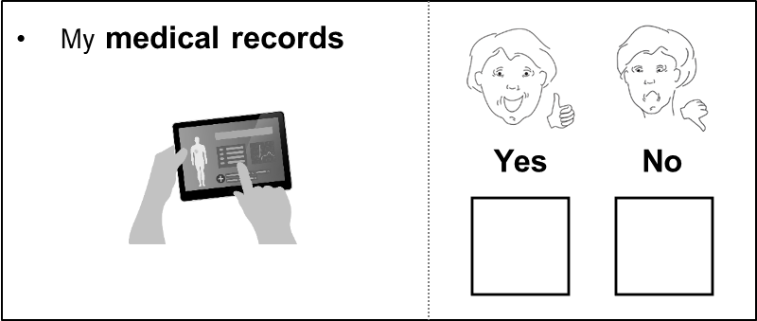
1b.

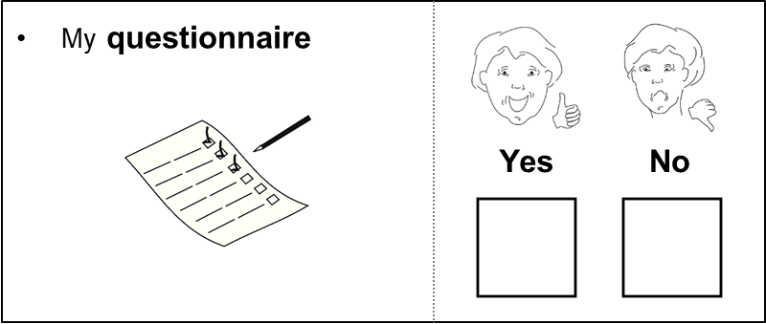
1c.
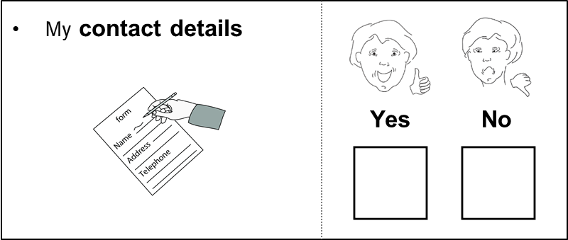
1d.

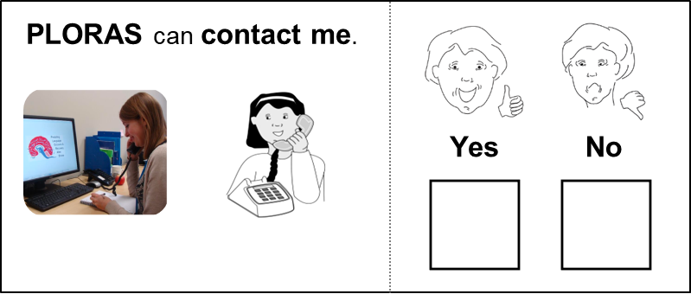
2.

Study sites:
- Complete signatures here only if Part 2 is not being completed with the participant.
- If also completing Part 2 with the participant, cross out these signature fields and sign in Part 2.
Participant signature*:
Date:
Name of research practitioner taking consent:
Signature:
Date:
If applicable, Independent witness details:
Name:
Occupation:
Signature:
Date:

Part 2: Further consent
- The relevant boxes below should be initialled by the participant.
- Please see note on Page 5 on when an Independent witness may be appropriate.

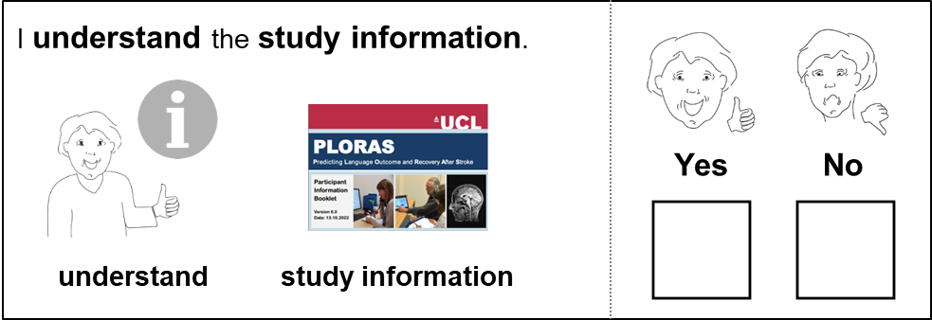
3.

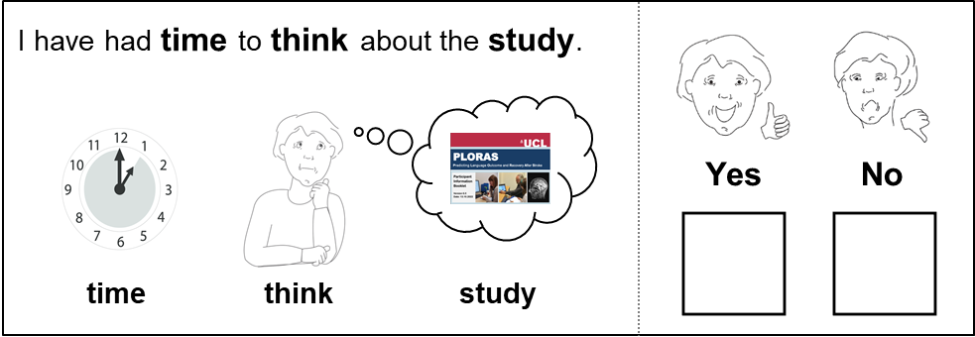
4.

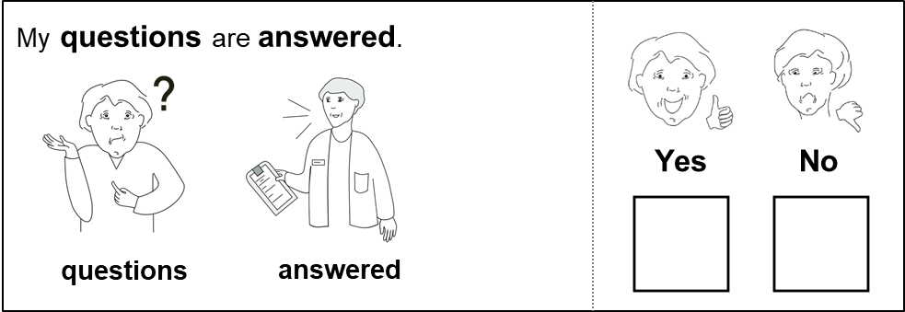
5.
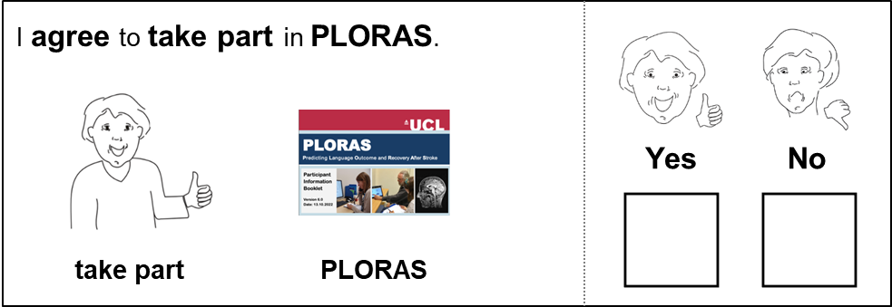
6.

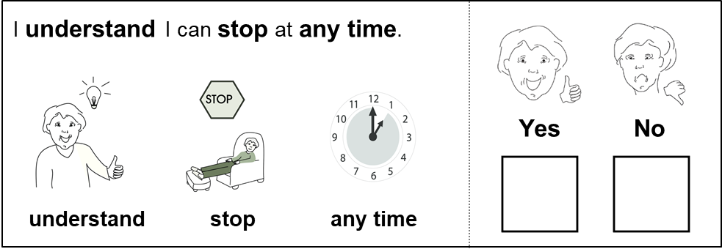
7.
Independent witnesses: an independent witness (someone who is not involved in the study) should complete their details in the signature section if the:

- Participant has capacity and can make a written mark (initial, signature) but it is not legible.
- Participant has capacity and cannot make any written mark but can indicate ‘yes’ or ‘no’ through other means (e.g. spoken, gesture). The witness should note this in the relevant box (e.g. write ‘spoken’ in the Yes box).

Participant cannot make any written mark but can indicate ‘yes’ or ‘no’ through other means (e.g. spoken, gesture). Please add a note next to each statement to document the participant's response and method (e.g. spoken/gestured 'yes').
[Grab your reader’s attention with a great quote from the document or use this space to emphasize a key point. To place this text box anywhere on the page, just drag it.]
Participant signature*:
Date:
Name of research practitioner taking consent:
Signature:
Date:
If applicable, Independent witness details:
Name:
Occupation:
Signature:
Date:

