## 

[GP / Trust / Organisation address]

[Insert patient’s name and address]

[Insert DD/MM/YYYY]

Dear [Insert patient’s name]

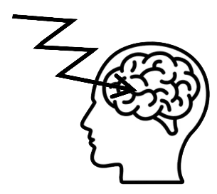**



**PLORAS**  is a **stroke study** at **UCL**

The **PLORAS** research team **studies** **communication difficulties**



You can **take part** or **not**

If you choose to **take part**:

We ask you **questions**

**

We send your **information** to **PLORAS**

**Contact details Brain scan**

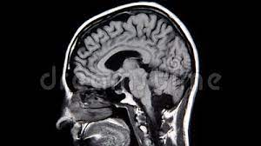



**Questionnaire Medical records**

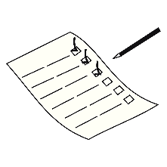

**PLORAS** will **contact** you

**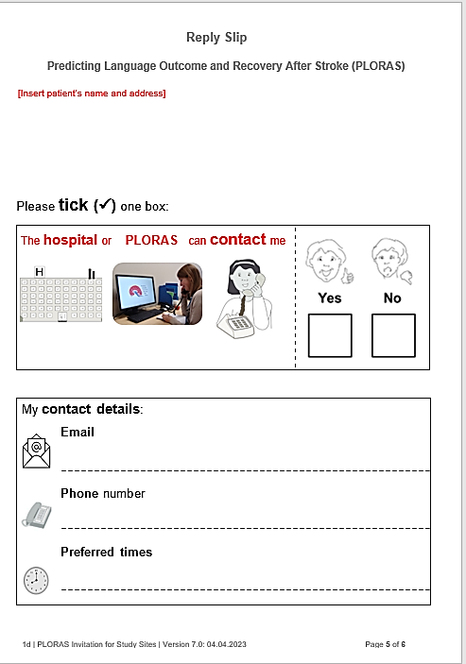How to **take part:**

If you have **questions:**

**contact us** or **contact PLORAS**



**Insert contact details of research practitioner**

**Insert email address of research practitioner**

0207 813 1538

or

07984 111 585

ploras@ucl.ac.uk



www.ucl.ac.uk/ploras

Please **complete** the **reply slip** and **post** it.

Yours sincerely,

[Insert: **Name** of research practitioner]

Enclosed:

* Reply slip
* Pre-paid reply envelope

**Picture credits:** see www.ucl.ac.uk/ploras/picture-credits

[Insert patient’s name and address]

Please **tick (✓)** one box:

|  |  |
| --- | --- |
| A person talking on the phone  Description automatically generated with low confidenceA person on the phone looking at a computer screen  Description automatically generatedA building with windows and a letter h  Description automatically generated  The **hospital**  or **PLORAS** can **contact** me |  |

My **contact details**:

**Email**

**Phone** number

**Preferred times**



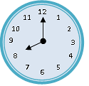

Please **tick (✓)** one box:

|  |  |
| --- | --- |
| A building with windows and a letter h  Description automatically generatedA person on the phone looking at a computer screen  Description automatically generated  The **hospital** or **PLORAS** can **contact someone else** |  |

**Contact details** for **someone else**:

(Please **check** they are **happy to be contacted**)

Their **name**

**Relationship** to **me**

**Email**

**Phone** number

